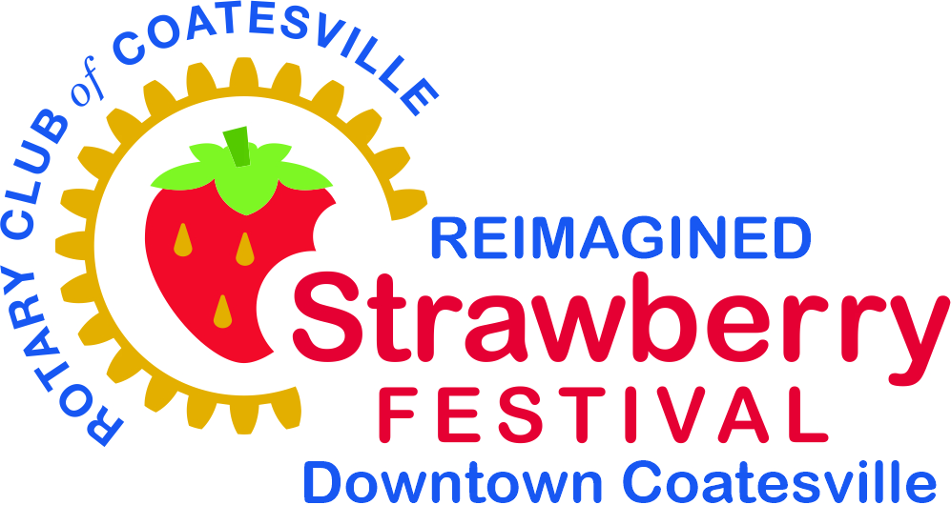
2026 Rotary Club of Coatesville
Reimagined Strawberry Festival Downtown Coatesville
Benefiting the Rotary Club of Coatesville Foundation
June 5th and 6th
Sponsor Reply Form

YES! My company would like to sponsor the
2026 Reimagined Strawberry Festival Downtown Coatesville

Company Name: Website:
Contact:
Address:
City: State: Zip:
Phone: Email:
(Please make additions and corrections as necessary)

Name as you would like it to appear in ALL promotional materials:

_________________________________________________________________________________________________________

We wish to support and participate in the Strawberry Festival in the following manner (please check one):
❐ Presenting Sponsor $7,500  Strawberry Shortcake Sponsor $500
❐ Midway Sponsor $5,000  Rotary Club Sponsor $250
❐ Entertainment Sponsor $2,500  Festival Friend Sponsor $100
❐ Strawberry Drop Zone Sponsor $1000
❐ I am please to make a donation in the amount of $_____________

SUBMIT A SPONSOR FORM:
By Email: Complete the above form and email it to rotarystrawberryfestival@gmail.com .
By Mail: Print the above completed application and mail to:
Rotary Club of Coatesville, 279 Hurley Road, Coatesville, PA 19320.

PAYMENT OPTIONS:
Credit Card: Scan the QR code below or click this link: PayPal Donation. Complete credit card information and submit your payment.
Check/Money Order: Make check/money order payable to Rotary Club of Coatesville Foundation. Send your check to Rotary Club of Coatesville, 279 Hurley Road, Coatesville, PA 19320

Questions? Please contact Greg Krajewski, Sponsorship Committee
@ 484-364-1071 or e-mail: rotarystrawberryfestival@gmail.com

Kindly confirm your support by May 15 for inclusion in the festival guide
Thank you for supporting the Coatesville community!

